

American International University- Bangladesh

CSC 3222: Web Technologies

CO1.1 and CO2.1 Evaluation

Project Report

Spring 20-21

Project Title: ABC.COM

Section: I

|  |  |
| --- | --- |
| Student Name | Student Id |
| Dip, Ahmed Rasidun Bari | 17-35216-2 |
| Samiha Nowrin | 17-35419-3 |
| S.R.M.BAHAUDDIN SHISHIR | 18-38327-2 |
| Tabassum, Shakira | 18-38094-2 |

**ABC.COM**

Introduction:

Nowadays people are so busy that they don't have enough time to go to the store. So, we are developing an e-commerce website named ABC.COM so that people can buy their favorite products from home. This project is an attempt to provide the advantages of online shopping to customers of a real shop. It helps buying the products in the shop anywhere through internet by this website.

Background Study:

In this project we are developing an E-commerce named ABC.COM website for mass people. In our project we have four types of users and different types of features are included. For this project we get the functionality ideas from EVALY.COM, AMAZON.COM and DARAZ as reference and we are trying to implement those in our project. The users of this project are: Admin, Manager, Buyer, and Seller. All users have some common functionality like, every user can register and login to the system and they also can edit, delete or view their profile by themselves.

Requirement Analysis:

**1. User Category:**

There are four types of users here. They are-

* Admin
* Manager
* Seller
* Buyer

**Common Features for all user:**   
**1.**All users can register and login to the system.  
**2.** Can search and view the categories, sub-categories, brands and products.   
**3.** Can manipulate their own profile information like edit, delete and view.

**Functionalities of Admin:**

**1.** Can add/delete seller, buyer and manager.  
**2.** Can verify Buyer/Seller/Manager profiles and also can block buyer and seller.

**3.** Can add, delete and view the information of seller and manager.

**4.** Can change site name, site logo, site title, site description, contact details and so on.  
**5.** Can View order information, order number, purchase details and so on.

**Functionalities of Manager:**

**1.** Manager can add/delete category, sub-category and brand of products.

**2.** Can manipulates product information and update product status.

**3.** Can update the delivery status.

**4.** Can add coupon code for the products.

**Functionalities of Seller:**

**1.** Seller can add or publish the product.

**2.** Can edit product information.

**3.** Can see the delivery information.

**4.** Can contact with admin and manager.

**Functionalities of Buyer:**

**1.** Buyers can add products to cart

**2.** Can buy product and can make a payment.  
**3.** Can provide review and comment.

Design:

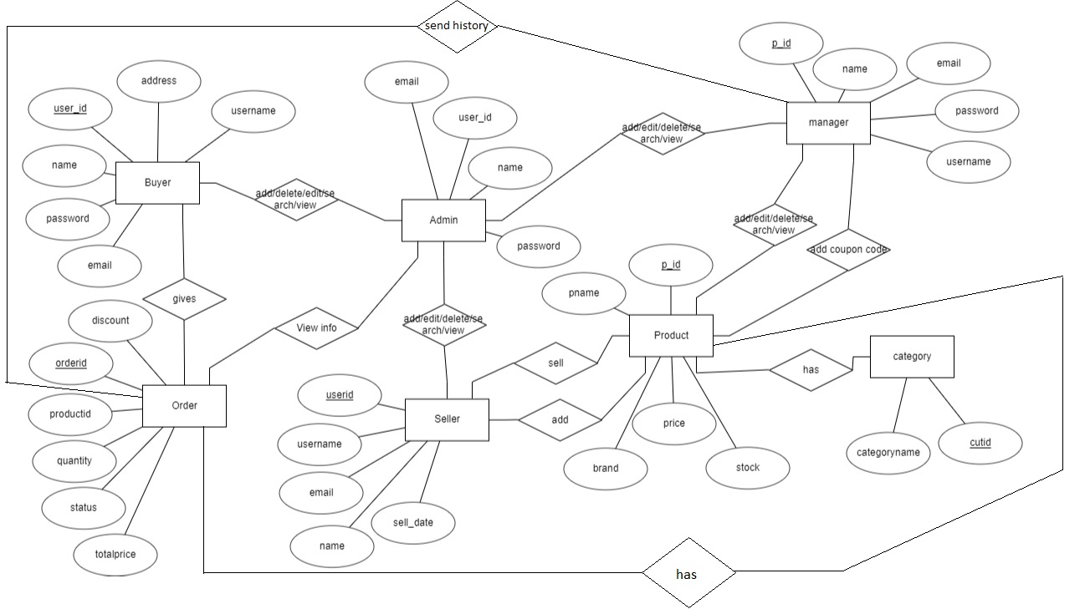

Tools Used:

* **Visual Studio Code -** It is a streamlined code editor.
* **Google chrome –** It is a free web browser, used for accessing web pages on the internet.
* **XAMPP -** It is a software distribution which provides the Apache web server.

System Images against the Specification:

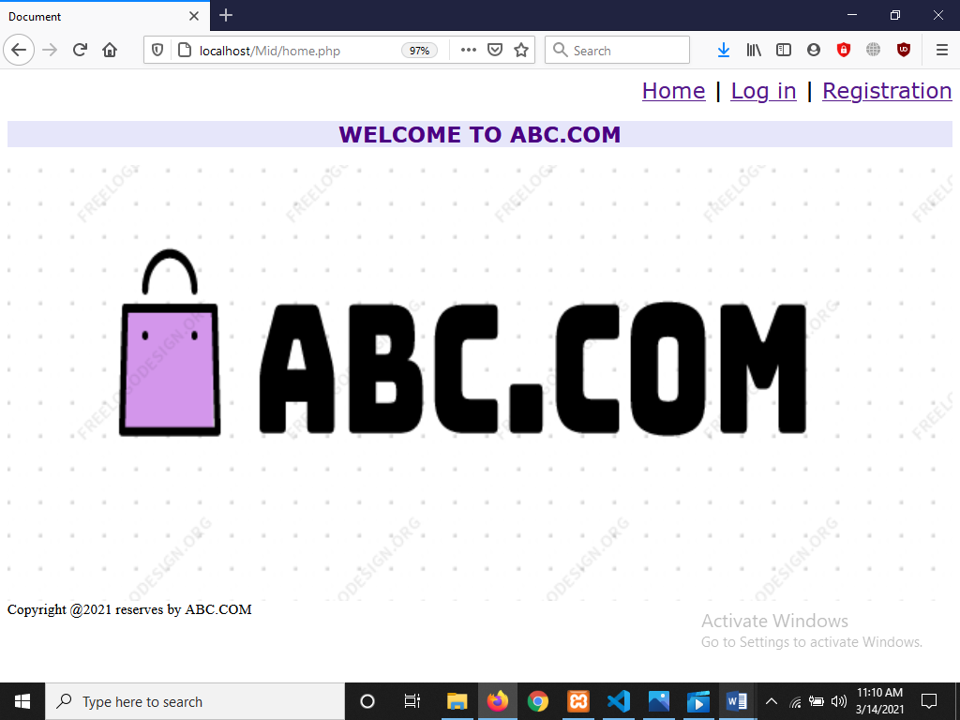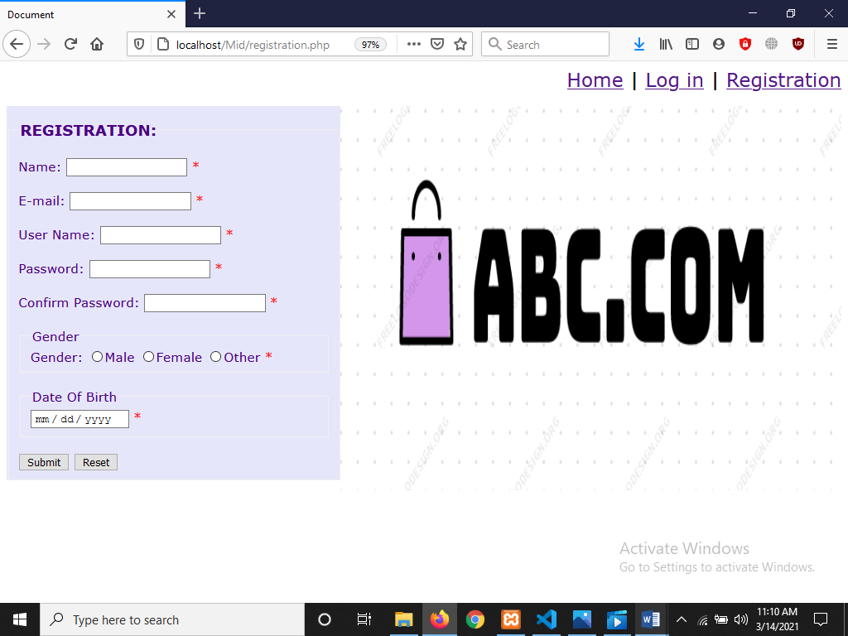

**Description:** Here the first GUI is the interface of home and the second GUI is the interface of registration module. Users can register themselves in the system by registering here.

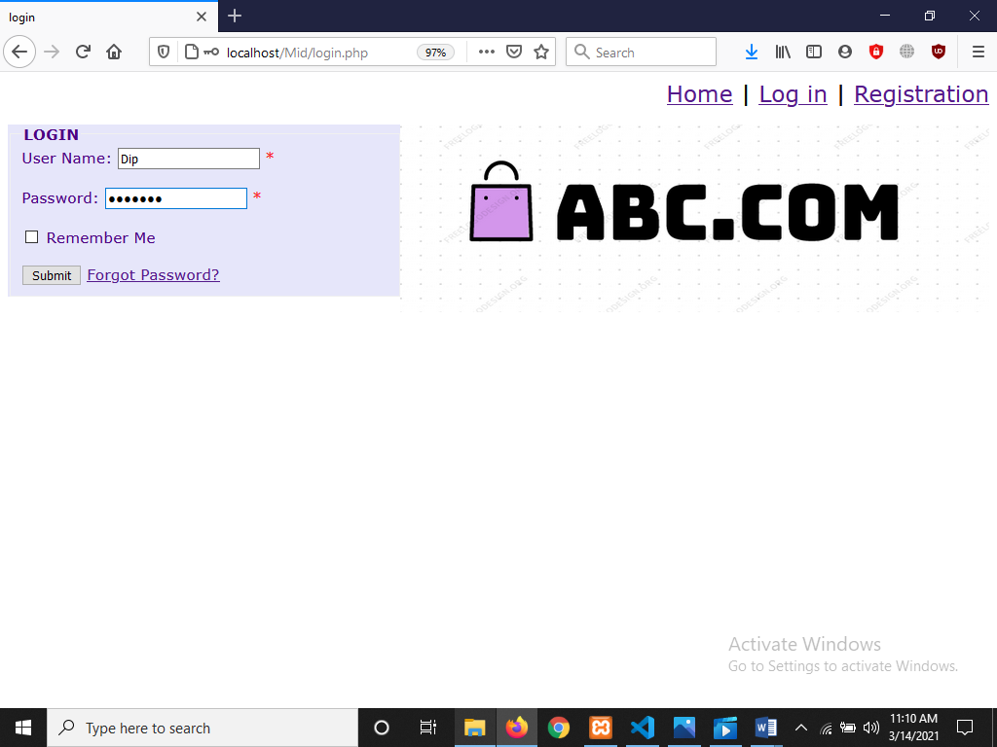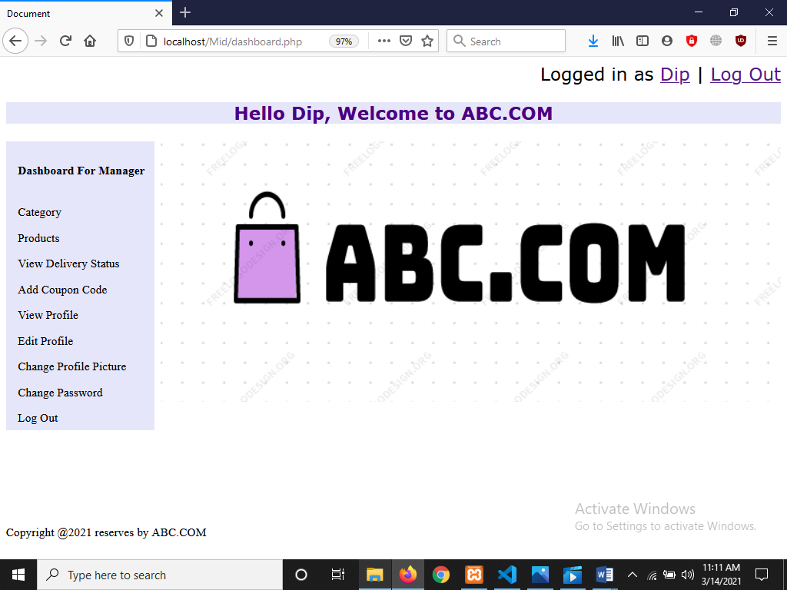

**Description:** Here the third GUI is the interface of login module and the forth GUI is the interface of dashboard. Users can login in to the system by login module.

Users can view dashboard by dashboard module.

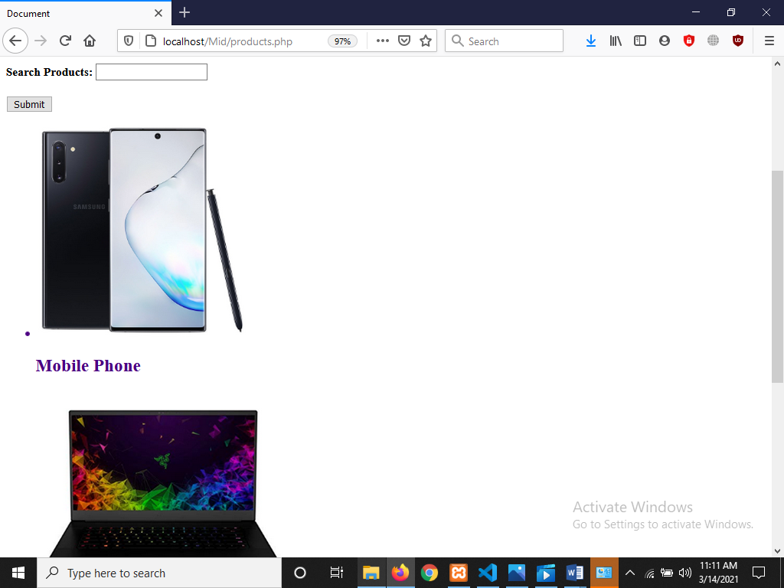

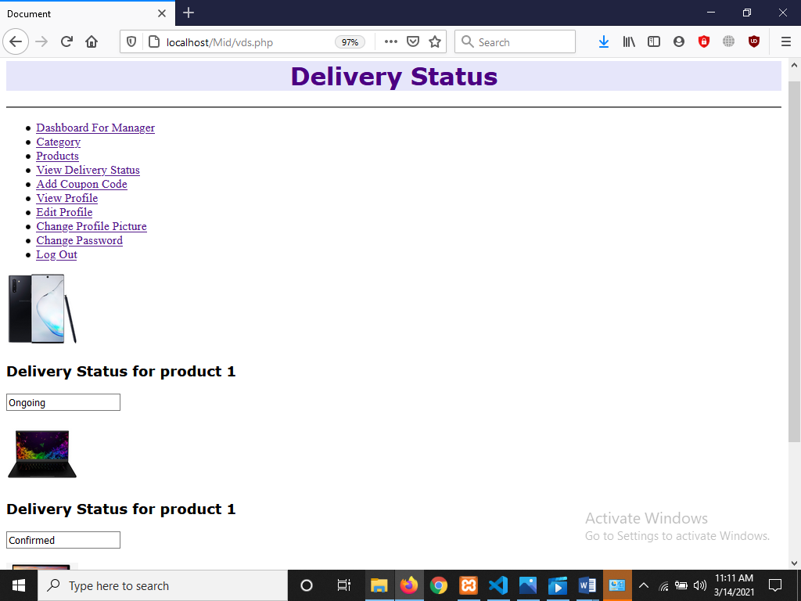

**Description:** Here the fifth GUI is the interface of products and the sixth GUI is the interface of delivery status. Users can search products by this module.

Users can view dashboard by dashboard module.

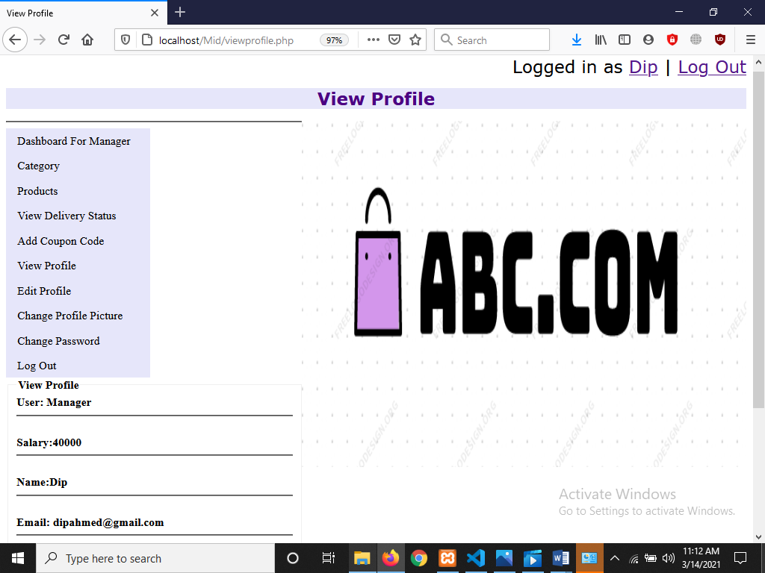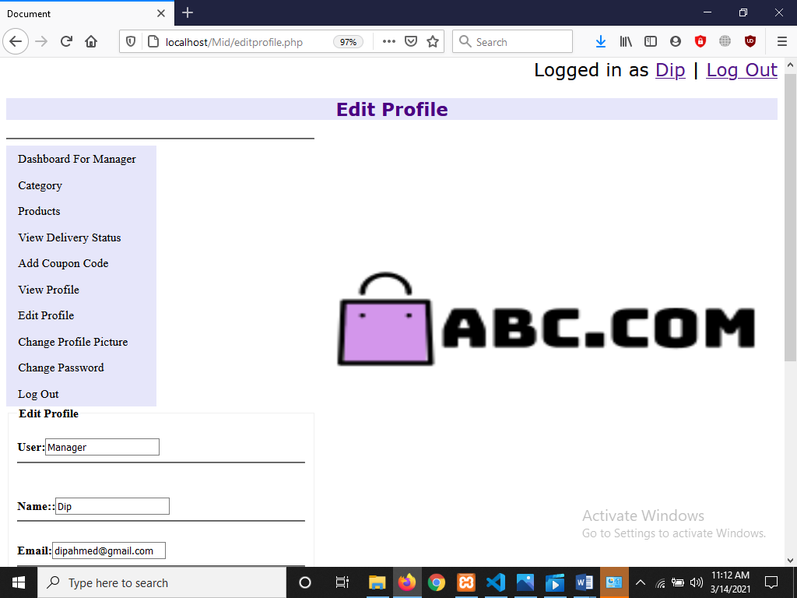

**Description:** Here the seventh GUI is the interface of view profile and the eighth GUI is the interface of edit profile. Users can view profile by this profile view module. Users can edit profile by edit profile module.

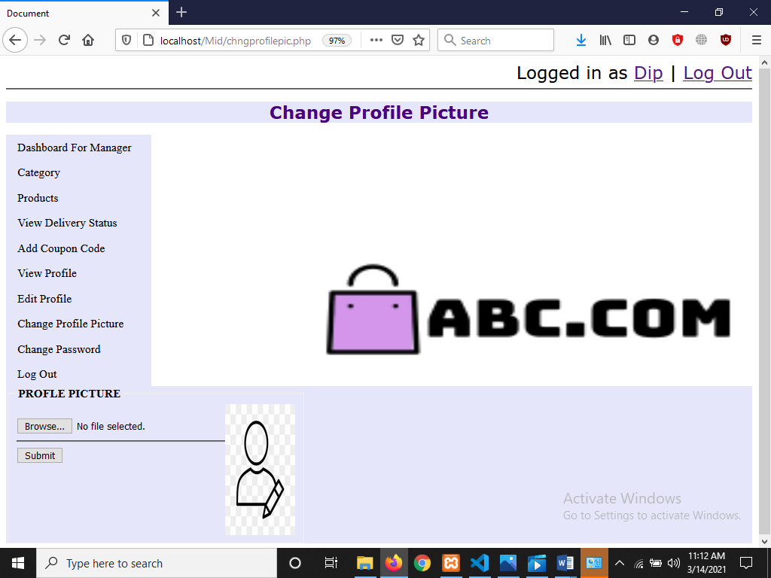

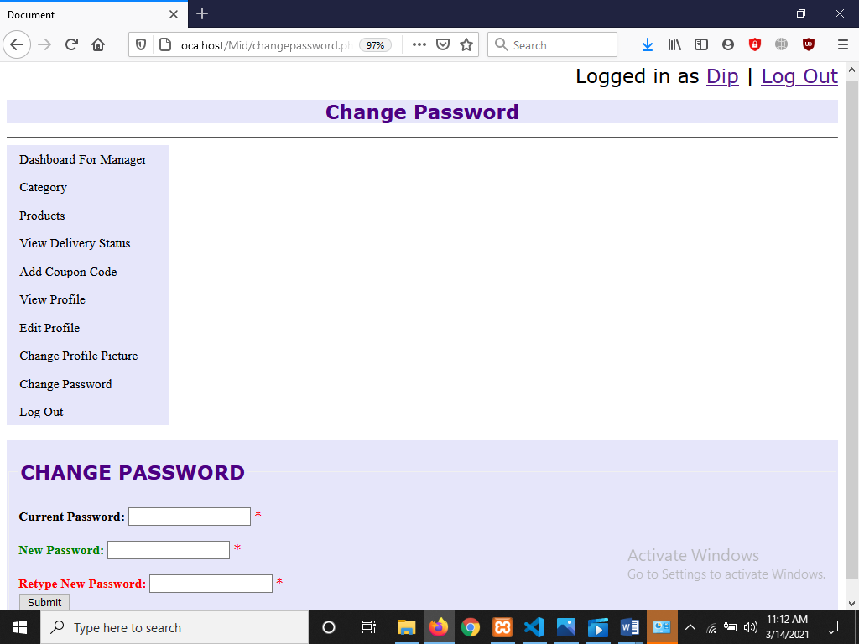

**Description:** Here the ninth GUI is the interface of changing profile picture and the tenth GUI is the interface of changing password for the users. Users can view profile by this profile view module. Users can edit profile by edit profile module.

Impact of this Project:

Today, in all aspects of our daily lives, the Internet has become an undivided part of our lives, as it has a versatile impact on our social activities. On the other hand there is no time, people has become too busy in his work. So, in these circumstances, our project can become an integral part of our society. This project offers buyers and sellers a new form of communication and provides an opportunity to create a new marketplace. In general it is suggested that the development of this project results in higher firm productivity and efficiency as a result of lower search and transaction costs.

Limitations and Possible Future Improvements:

The user interface of our project is not very well designed so it will be hard for the users to use. In future after learning CSS properly we will try to make our interface user friendly. Another limitation of our project is that we could not use voice search functionality to search a product. But in future it will be a great addition if we can add voice search functionality to search a product in our website. Our project is slightly less intimate and slightly less about personal experience than retail shopping. We don’t have someone who can help with the browsing and recommend products to us face-to-face. In future we will try to keep track of customers’ preferences and tailoring their ecommerce experience based on the things they like and are interested in.